Project Report

Alzheimer’s Detection using 3D Convolutional Neural Networks

Members:

Kalyan Kumar Paladugula ([kpalad4@uic.edu](mailto:kpalad4@uic.edu))

Sudha Anusha Sagi ([ssagi2@uic.edu](mailto:ssagi2@uic.edu))

Vignesh Narayanaswamy ([vnaray21@uic.edu](mailto:vnaray21@uic.edu))

Contents:

1. Abstract
2. About Alzheimer’s
3. Related Work
4. About 3D Convolutional Neural Networks
5. Our Models
6. Conclusion
7. List of Packages downloaded for the Project
8. References

**Abstract:**

Alzheimer’s disease, the most common form of dementia, is an irreversible, progressive brain disorder associated with permanent loss of memory and cognitive functioning. Mild Cognitive Impairment (MCI), another form of dementia, can be an early sign of Alzheimer’s. It is hard for humans to differentiate between MCI and AD. For this project, we are exploring models that could distinguish AD from MCI. We have three classes: Normal Controllers (NC), Mild Cognitive Impairment (MCI), and Alzheimer’s Disease (AD). Finally, we included a model based on 3D Convolutional Networks that performs well for all three classes.

**About Alzheimer’s:**

Alzheimer’s is the sixth-leading cause of death in the United States1. It is the only top-10 cause of death in the United States with no known cure. It is estimated the Alzheimer’s and other forms of dementia will cost $305 billion in 2020and the expenses are projected to reach $1.1 trillion (in 2020 dollars) by 20502. Currently, more than 5 million people in the US have Alzheimer’s and this number would reach 14 million by 20501. Someone in the US develops Alzheimer’s every 65 seconds2. By 2050 this is projected to go down to 33 seconds2. Alzheimer’s is not just a disease of old age: 200,000 people under age 65 have early-onset Alzheimer’s disease. It has a very high mortality rate: 1 in 3 seniors dies with Alzheimer’s or another dementia1. Although the mortality rates of the other major diseases decreased significantly, the deaths from Alzheimer's disease have increased significantly. Between 2000 and 2018, the number of recorded deaths from Alzheimer's increased by 246%, while the number of deaths from the number one cause of death (heart disease) decreased by 7.8%1.

AD is characterized by memory impairment, language dysfunction, and impairment of recognition so that AD patients always cannot manage themselves with neurofibrillary tangles4. Though some treatments may temporarily improve the symptoms of AD, there is still no powerful evidence that can tell the reason or can stop its progression5. As the condition getting worse, patients become more and more dependent on the help of others. This also puts a heavy burden on the caregiver, including social, psychological, physical and economic factors. It is found that, although AD is incurable, in its earlier stage, mild cognitive impairment patients may maintain the diagnosis of MCI even after many years3.

Since MCI could be an early sign of AD, great research has been made to develop techniques for early detection at pre-symptomatic stages to slow or prevent the progression to AD. Advanced neuroimaging techniques, such as magnetic resonance imaging (MRI), positron emission tomography (PET), Diffusion Tensor Imaging (DTI), Cerebrospinal Fluid Flow (CSF) test, have been developed to identify structural and molecular biomarkers6. But their high dimensionality and multi-modality make these techniques difficult to analyze for humans6. Hence, machine learning approaches have attracted significant attention in the field of high dimensional image analysis6. Pattern analysis methods, such as linear discriminant analysis (LDA), Principal Component Analysis (PCA), logistic regression (LR), support vector machine (SVM), and support vector machine recursive feature elimination (SVM-RFE), have been used for early detection of AD and the prediction of AD progression6.

However, in order to apply Machine Learning, we must do data pre-processing and feature engineering first. Since, these must be done manually before feeding the data to any machine learning model, which is time-consuming, another family of machine learning called Deep Learning has become prominent due to their automated nature. These deep learning techniques extract the biomarkers (most important features) on their own for classification. We just need to feed them the pre-processed data.

Before these advanced techniques, they used to segment the brain volume obtained from neuroimaging scans into gray matter (GM), White matter (WM), and cerebrospinal fluid (CSF). The gray matter was used to separate Alzheimer’s patients from Normal Controllers as GM has the strongest relationship with the diagnosis of AD and MCI3. Then the hippocampal volume, ventricular volume, whole-brain volume or cortical thickness are usually taken as features to identify AD from NC because the hippocampus volume of the AD patients is smaller than the healthy controllers; on the contrary, the ventricle of AD patients may be larger3.

**Related Work:**

We divided the methods used by the researchers into two types: Pure Deep Learning, and Hybrid Learning. In Pure Deep Learning, deep learning was used for both feature extraction and classification whereas in the Hybrid one, traditional machine learning models, like SVM, Logistic Regression and Multi-Kernel SVM, were used for classification. The former one gave better results when used on large datasets and the latter one in case of small datasets.

Some researchers converted the multi-classification problem to binary classification problem and used transfer learning later7. They first trained the models on only two classes: AD and NC.

Then after training the classifier with two classes, they added a new class MCI and fine-tuned the weights to accommodate this. This is possible because they used cross-entropy loss which could be extended to multi-class cases7. And they have shown that in the case of the limited training datasets the models with the transfer learning strategy yielded better results than the ones that classify the input into three classes from scratch. As MCI is the intermediate stage between the cognitive decline of normal aging and the more pronounced decline of AD, first learning to separate the AD and the NC then adding the third class and fine-tuning the network transfers the learned knowledge to classify the middle condition, not jeopardizing the performance of AD Diagnosis7.

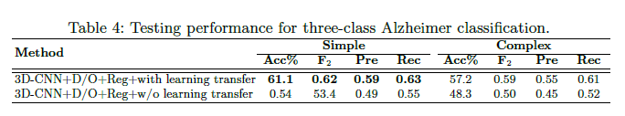7

And some further split the MCI class into two: MCI non-converters (ncMCI) or MCI converters (cMCI) based on the risk of progression to AD. In [8], they converted the three-class problem to four-class problem (NC, ncMCI, cMCI, and AD) and applied Pure deep learning with stacked sparse auto-encoders and a softmax regression layer. But they got low accuracy.

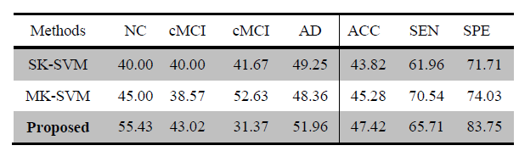8

Few researchers combined the neuroimaging techniques (MRI+PET, MRI+CSF, MRI+PET+CSF) to improve the accuracy and F1 scores. In [8], they extracted the grey matter volumes from MRI and CMRGlc patterns from PET. And in [10], they used the fusion of MRI, PET, and CSF.

Two or more multimodal neuroimaging data types (MRI+PET, MRI+PET+CSF) resulted in better accuracy6.

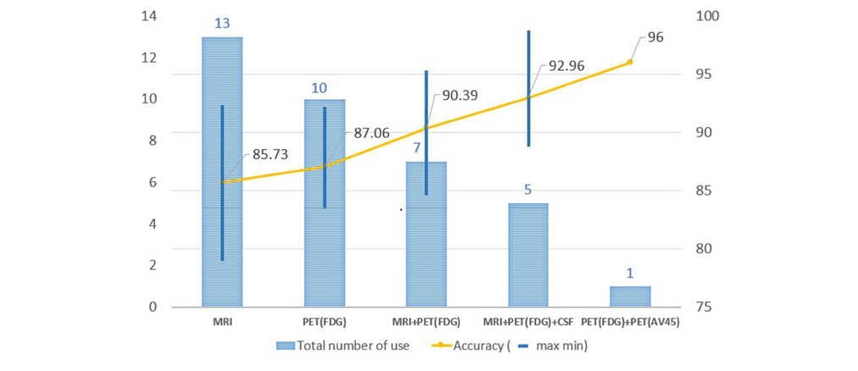

Some researchers used the drop-out technique to avoid the “weight co-adaptation” problem which is a typical cause of overfitting in Deep Learning9. It is possible that only a few weights are involved in giving you the desired output. But in this scenario, you will also be looking at only part of the features in the input. This is called "overfitting" and is a result of co-adaptation. Your network has adapted to the dataset. Neural Networks show a gradual decay in performance rather than a complete failure when some of the neurons are disabled (or killed in the case of biological neurons). Basically, a subset of the connections is enough to give the desired output by the network.

To prevent this from happening, a solution is to introduce dropout: during training, disable (multiply by some value [0,1]) the output of some of the neurons. This makes sure the rest of the neurons are "forced" to do something or learn to classify the dataset. At every epoch, you dropout a random set of neurons with probability p (the only parameter of a dropout layer). This makes the remainder of the 1−p fraction of the neurons to also learn the feature set. Since you are no longer depending on only a few features or weights, you can escape the overfitting problem.

The dropout technique improved the accuracy of the models7.

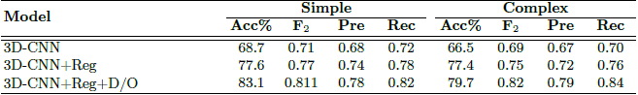7

Some researchers used F1-Score instead of accuracy to improve the recall of AD and MCI classes. As it is difficult to differentiate AD and MCI classes, even if we get high accuracy, we might not get good accuracy on AD and MCI classes (Ex: 84% accuracy - 99% on NC, 70% on MCI, and 80% on AD). If the F1-score is used to pick the best model, we would get better recall scores on all the three classes.

**List of Packages downloaded for the Project:**

TensorFlow

We used the following packages for the project:

Os

Numpy

Pandas

Matplotlib

Sklearn

TensorFlow

**References:**

1. <https://www.alz.org/alzheimers-dementia/facts-figures#quickFacts>
2. Alzheimer’s Association: [2019 Alzheimer’s Disease Facts and Figures](https://www.alz.org/alzheimers-dementia/facts-figures" \t "_blank)
3. [Auto-Detection of Alzheimer's Disease Using Deep Convolutional Neural Networks](https://ieeexplore.ieee.org/document/8687207)
4. DaoqiangZhang, DinggangShena and The Alzheimer's Disease Neuroimaging Initiative, “Multi-modal multi-task learning for joint prediction of multiple regression and classification variables in Alzheimer's disease, ” NeuroImage, Volume 59, Issue 2, Pages 895-907,16 January 2012.
5. Manhua Liu, Daoqiang Zhang, Dinggang Shen, and The Alzheimer's Disease Neuroimaging Initiative, “Ensemble sparse classification of Alzheimer's disease,” NeuroImage, vol. 60, 1106–1116, January 2012.
6. [Deep Learning in Alzheimer’s Disease: Diagnostic Classification and Prognostic Prediction Using Neuroimaging Data](https://www.frontiersin.org/articles/10.3389/fnagi.2019.00220/full)
7. [End-To-End Alzheimer’s Disease Diagnosis and Biomarker Identification - Soheil Esmaeilzadeh, Dimitrios Ioannis Belivanis, Kilian M. Pohl, and Ehsan Adeli](https://www.google.com/url?sa=t&rct=j&q=&esrc=s&source=web&cd=1&cad=rja&uact=8&ved=2ahUKEwjU77-UxZPpAhVaCs0KHY4EABIQFjAAegQIBhAB&url=https%3A%2F%2Fweb.stanford.edu%2F~eadeli%2Fpublications%2FMICCAI_DeepAD_Final.pdf&usg=AOvVaw2U7Hssm5i4NqA8r3uqECXl)
8. [Early diagnosis of Alzheimer's disease with deep learning](https://ieeexplore.ieee.org/document/6868045)
9. [A Robust Deep Model for Improved Classification of AD/MCI Patients](https://ieeexplore.ieee.org/document/7101222)